1. Complete the steps in Section 1, “Initialize Network Monitoring Applications.”
2. Continue with Section 2, “Test IDS Results with Regular Nmap Scan,” and capture screenshots of the following:
   1. Step 9 output.

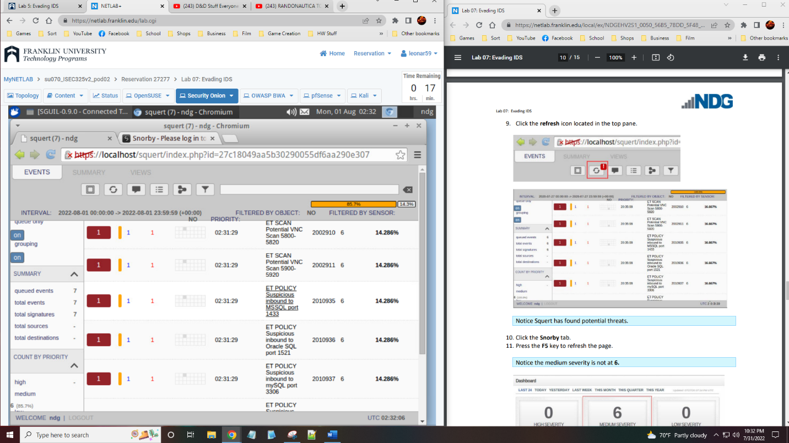

* 1. Step 13 output

1. Continue with Section 3, “Test IDS Results with Decoy Scan,” and capture screenshots of the following:
   1. Step 6 output

* 1. Step 10 output

1. Continue with Section 4, “Test IDS Results with Spoofed MAC Scan,” and capture screenshots of the following:
   1. Step 4 Snorby scan output

* 1. Step 4 Squert output

1. Summary and Reflection: In a few paragraphs, reflect on what you learned through this lab assignment. Was there anything surprising or unexpected? Was there anything worth investigating further?

This lab was interesting as we got to see how even if the same system is running the programs, they may not see the same thing. This is shown a lot as the results are different as not all of them fall for the decoy, but they do not all pass the decoy by. The idea of spoofing has been talked about a lot more as people will use it for security or even to show up at a different location in a mobile or computer game. For instance, with the Pokemon Go mobile game, they wanted to get people to trade with those in other countries by making some pokemon only appear in those places. A lot of people could not afford to travel or could trade with someone from these areas so they would use spoofing to change their location and the app would believe they are in the new place making it easier to catch all the pokemon available.